Additional File

Tables

Table 1. Odds ratios (OR) of the association between parental education and energy-dense food intake stratified by perceived weight status, girls aged 11-17
 | No. in sample |  | Low intake of energy-dense food
 |  |  | OR 95% CI
Stratified analysis by perceived weight status ª
fat | 815
Primary education | 176 |  | 1.0
Secondary education | 467 |  | 1.2 (0.8-1.8)
Tertiary education | 172 |  | 1.6 (1.0-2.5)
normal | 1896
Primary education | 317 |  | 1.0
Secondary education | 1021 |  | 1.4 (1.0-2.0)*
Tertiary education | 558 |  | 2.6 (1.8-3.6)*
thin | 382
Primary education | 76 |  | 1.0
Secondary education | 207 |  | 1.3 (0.6-2.8)
Tertiary education | 99 |  | 1.9 (0.8-4.7)
ª Models adjusted for age groups and regional strata east vs. west Germany. * Significant on a 95% level of confidence.

Table 2. Odds ratios (OR) of the association between parental education and HuSKY stratified by total energy expenditure, girls aged 11-17
 | No. in sample |  | High HuSKY
 |  |  | OR 95% CI
Stratified analysis by total energy expenditure ª
low | 947
Primary education | 197 |  | 1.0
Secondary education | 548 |  | 1.2 (0.8-1.7)
Tertiary education | 202 |  | 1.2 (0.8-2.09)
middle | 961
Primary education | 180 |  | 1.0
Secondary education | 526 |  | 0.7 (0.5-1.1)
Tertiary education | 255 |  | 1.3 (0.8-2.1)
high | 955
Primary education | 143 |  | 1.0
Secondary education | 497 |  | 1.0 (0.7-1.5)
Tertiary education | 315 |  | 2.2 (1.5-3.4)*
ª Models adjusted for age groups and regional strata east vs. west Germany. * Significant on a 95% level of confidence.

Table 3. Mediation analyses of the association between parental education and low intake of energy-dense food ª adjusted for media use and familial leisure activity, boys and girls aged 11-17

 | Basic Model; age + region + parental education |  | Model 1; Basic Model + media use |  | Model 2; Basic Model + familial leisure activity
 | OR 95% CI P-value |  | OR 95% CI P-value |  | OR 95% CI P-value
Boys
Parental education
primary | 1.0 |  | 1.0 |  | 1.0
secondary | 1.55 (1.22-1.97) 0.000 |  | 1.48 (1.16-1.90) 0.002 |  | 1.51 (1.19-1.91) 0.001
tertiary | 2.41 (1.95-2.99) 0.000 |  | 2.18 (1.75-2.72) 0.000 |  | 2.32 (1.88-2.88) 0.000
Media use
low |  |  | 1.0
middle |  |  | 0.67 (0.55-0.81) 0.000
High |  |  | 0.45 (0.36-0.57) 0.000
missing |  |  | 0.67 (0.44-1.00) 0.053
Familial leisure activity
high |  |  |  |  | 1.0
low |  |  |  |  | 0.87 (0.74-1.03) 0.100
missing |  |  |  |  | 0.64 (0.41-0.99) 0.043
Girls
Parental education
primary | 1.0 |  | 1.0 |  | 1.0
secondary | 1.31 (1.05-1.64) 0.017 |  | 1.27 (1.01-1.59) 0.038 |  | 1.26 (1.01-1.57) 0.037
tertiary | 2.10 (1.65-2.67) 0.000 |  | 1.84 (1.44-2.35) 0.000 |  | 1.99 (1.56-2.54) 0.000
Media use
low |  |  | 1.0
middle |  |  | 0.72 (0.60-0.87) 0.001
high |  |  | 0.38 (0.31-0.47) 0.000
missing |  |  | 0.82 (0.54-1.23) 0.326
Familial leisure activity
high |  |  |  |  | 1.0
low |  |  |  |  | 0.82 (0.70-0.97) 0.018
missing |  |  |  |  | 0.45 (0.29-0.69) 0.000
ª Energy-dense food intake is defined as ‘low’ using the lower limit of the 3rd quintile as the cut-off point dividing the population in 40% versus 60%.

Table 4. Mediation analyses of the association between parental education and a high HuSKY ª adjusted for media use and total energy expenditure, boys and girls aged 11-17

 | Basic Model; age + region + parental education |  | Model 1; Basic Model + media use |  | Model 2; Basic Model + total energy expenditure
 | OR 95% CI P-value |  | OR 95% CI P-value |  | OR 95% CI P-value
Boys
Parental education
primary | 1.0 |  | 1.0 |  | 1.0
secondary | 0.89 (0.72-1.11) 0.294 |  | 0.87 (0.71-1.09) 0.222 |  | 0.88 (0.71-1.09) 0.237
tertiary | 1.47 (1.15-1.88) 0.002 |  | 1.42 (1.11-1.81) 0.006 |  | 1.43 (1.12-1.82) 0.005
Media use
low |  |  | 1.0
middle |  |  | 0.84 (0.69-1.04) 0.103
high |  |  | 0.77 (0.62-0.95) 0.017
missing |  |  | 0.83 (0.55-1.26) 0.380
Total energy expenditure
low |  |  |  |  | 1.0
middle |  |  |  |  | 1.41 (1.14-1.73) 0.001
high |  |  |  |  | 1.46 (1.18-1.80) 0.001
missing |  |  |  |  | 1.19 (0.83-1.68) 0.340
Girls
Parental education
primary | 1.0 |  | 1.0 |  | 1.0
secondary | 0.94 (0.75-1.18) 0.589 |  | 0.92 (0.74-1.16) 0.484 |  | 0.91 (0.73-1.14) 0.408
tertiary | 1.61 (1.26-2.06) 0.000 |  | 1.49 (1.16-1.91) 0.002 |  | 1.49 (1.17-1.91) 0.002
Media use
low |  |  | 1.0
middle |  |  | 0.75 (0.61-0.94) 0.011
high |  |  | 0.57 (0.46-0.71) 0.000
missing |  |  | 1.14 (0.75-1.74) 0.544
Total energy expenditure
low |  |  |  |  | 1.0
middle |  |  |  |  | 1.34 (1.08-1.65) 0.007
high |  |  |  |  | 1.95 (1.59-2.39) 0.000
missing |  |  |  |  | 1.77 (1.28-2.43) 0.001
ª Healthy Nutrition Score for Kids and Youth (HuSKY) is defined as ‘high’ using the upper limit of the 3rd quintile as the cut-off point dividing the population in 40% versus 60%.

Figures

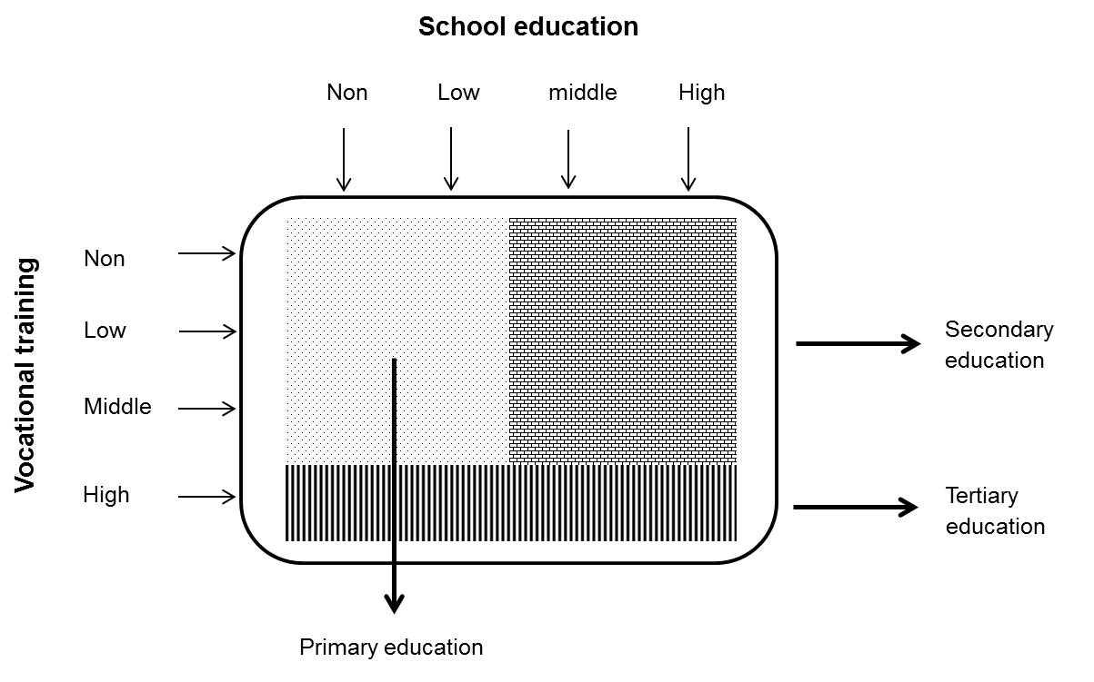

Figure 1. Level of education assessment, according to Schroedter, Lechert and Lüttinger 2006 (1)

References

(1) Schroedter JH, Lechert Y, Lüttinger P. Die Umsetzung der Bildungsklassifikation CASMIN für die Volkszählung 1970, die Mikrozensus-Zusatzerhebung 1971 und die Mikrozensen 1976-2004 [Transformation of the CASMIN education classification for the census 1970, the micro-census supplement 1971 and the micro-censuses 1976-2004] ZUMA Methodenbericht. 2006;12:1-58.

