Additional file 1: Figure S1

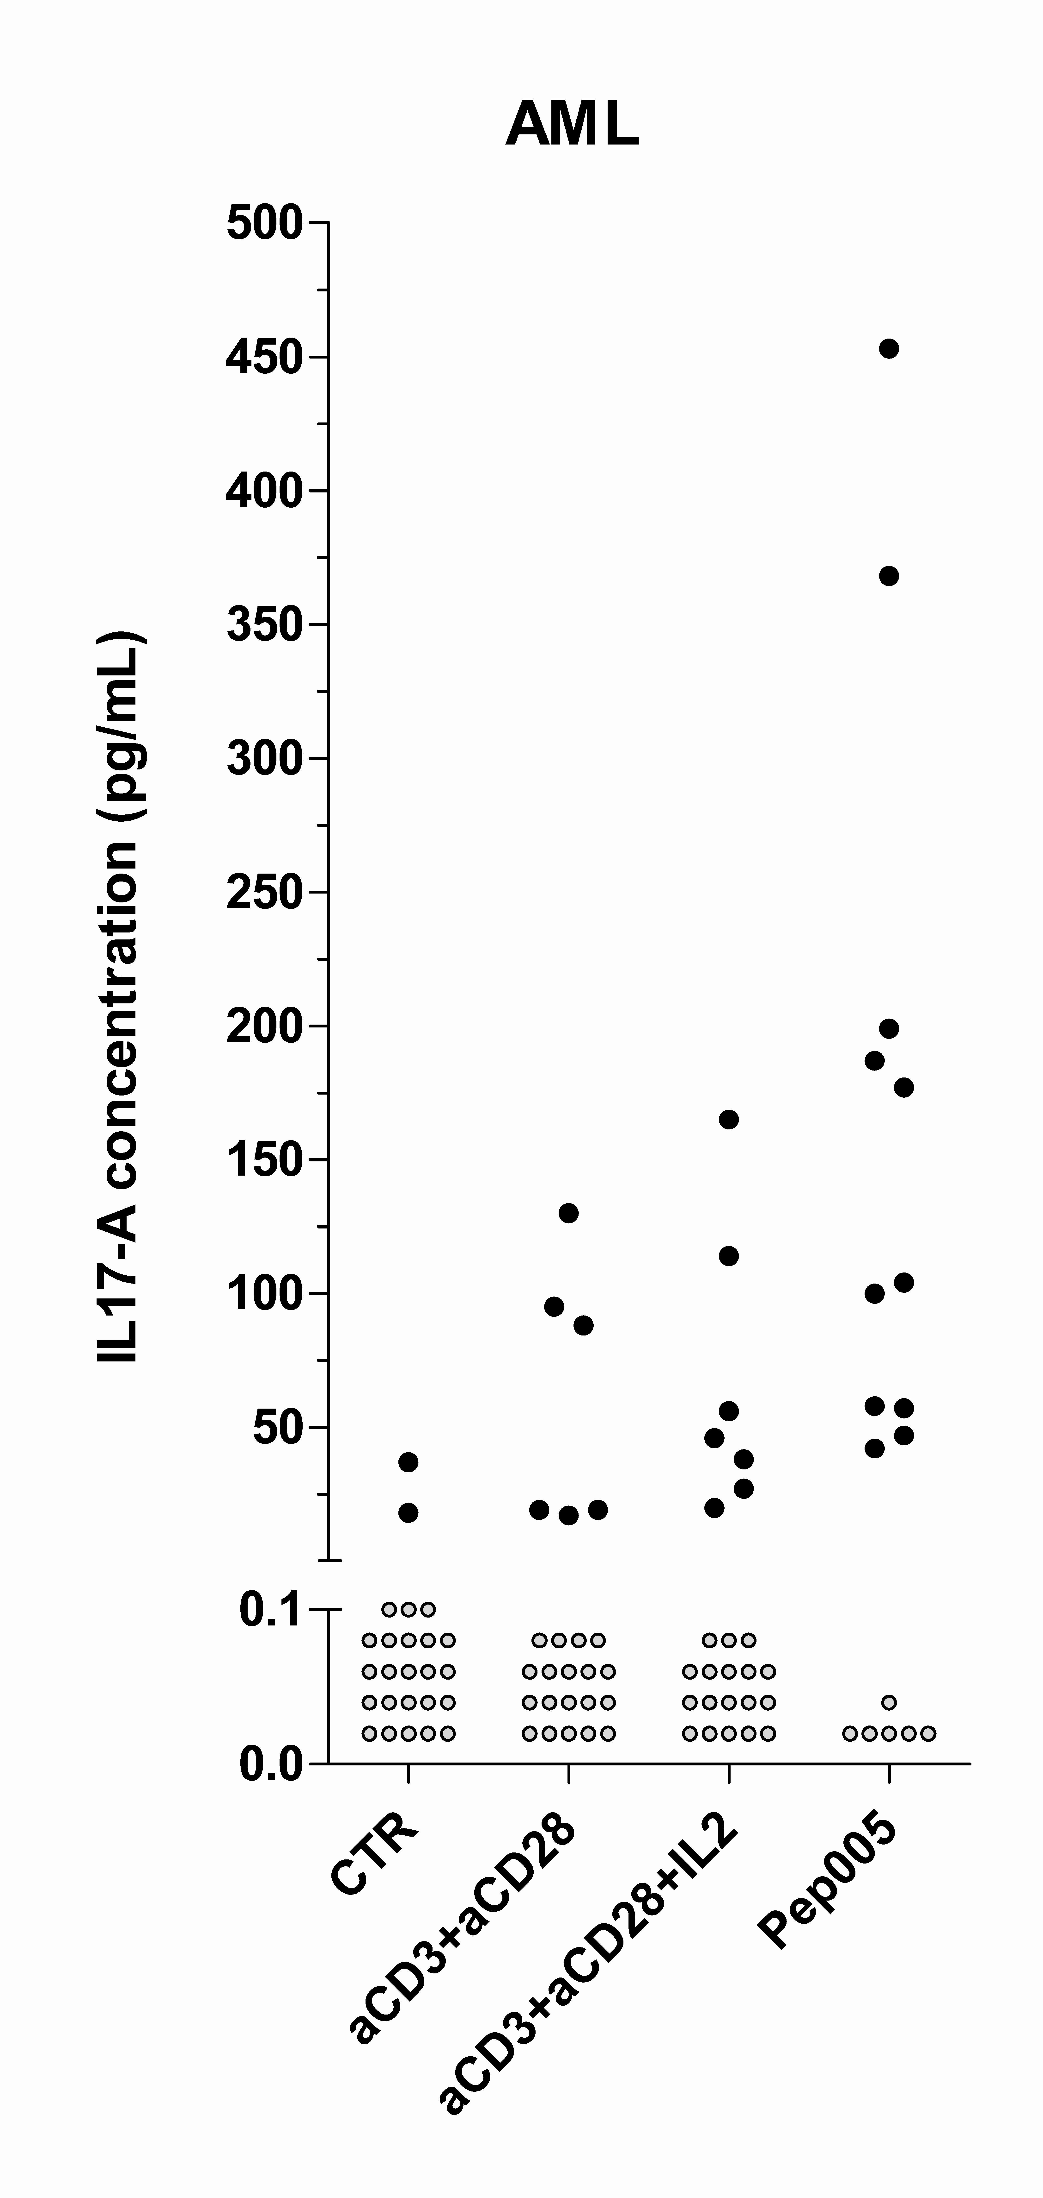
Release of IL17-A by T cells derived from AML patients with chemotherapy-induced cytopenia. Peripheral blood leukocytes were cultured in the whole blood assay and IL17-A levels determined in the culture supernatants. The leukocytes were cultured in medium alone (CTR), or medium with aCD3 + aCD28 or aCD3 + aCD28 + IL2. A subset of samples were also added the PKC agonist Pep005 in combination with aCD3 + aCD28 + IL2 (denoted Pep005). Results are presented as the cytokine concentration for each sample. Grey circles represent levels below the minimum detectable concentration (<15 pg/mL), and black circles represent detectable levels.

